Chapter 7.7 Lab: Controlling Access to Files

Marko Shaffer

Information Technology, Franklin University

ITEC 200: Linux Fundamentals

Professor Kagan Ulucay

6/15/2023

Red Hat System Administration I 8.2

Lab 05 CH 7.7 – Lab: Controlling Access to Files

**Performance Checklist:**

In this lab, you will configure permissions on files and set up a directory that users in a particular group can use to conveniently share files on the local file system.

**Outcomes:**

You should be able to:

* Create a directory where users can work collaboratively on files.
* Create files that are automatically assigned group ownership.
* Create files that are not accessible outside of the group.

Log in to workstation as student using student as the password.

|  |  |  |  |
| --- | --- | --- | --- |
|  | Franklin VM: | Standard User Account: | The Student's Root Account: |
| Username | kiosk | student | root |
| Password | redhat | student | redhat |

<https://franklin.instructure.com/courses/12488/modules/items/683350>

[kiosk@foundation0 ~]$ rht-vmctl start all

[kiosk@foundation0 ~]$ rht-vmview view workstation

On workstation, run the lab perms-review start command. The command runs a start script that determines if serverb is reachable on the network. The script also creates the techdocs group and three users named tech1, tech2, and database1.

**[student@workstation ~]$ lab perms-review start**

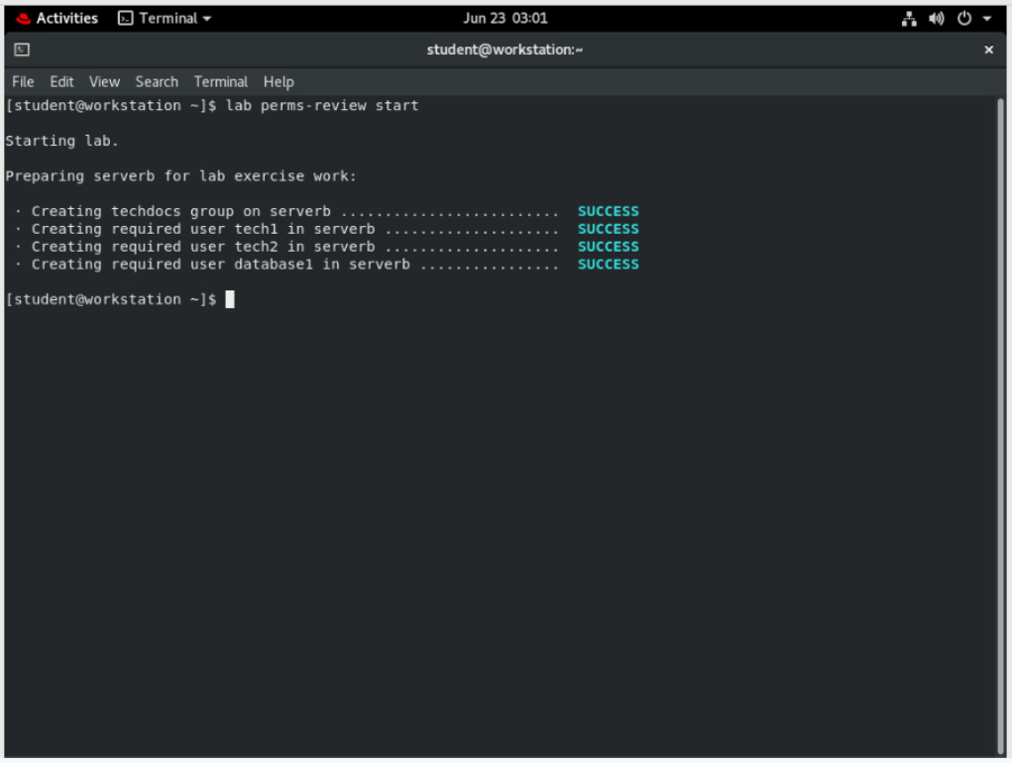

1. Use the ssh command to log in to serverb as the student user. Switch to root on serverb using redhat as the password.

**[student@workstation ~]$ ssh student@serverb**

*...output omitted...*

**[student@serverb ~]$ su -**

Password: **redhat**

**[root@serverb ~]#**

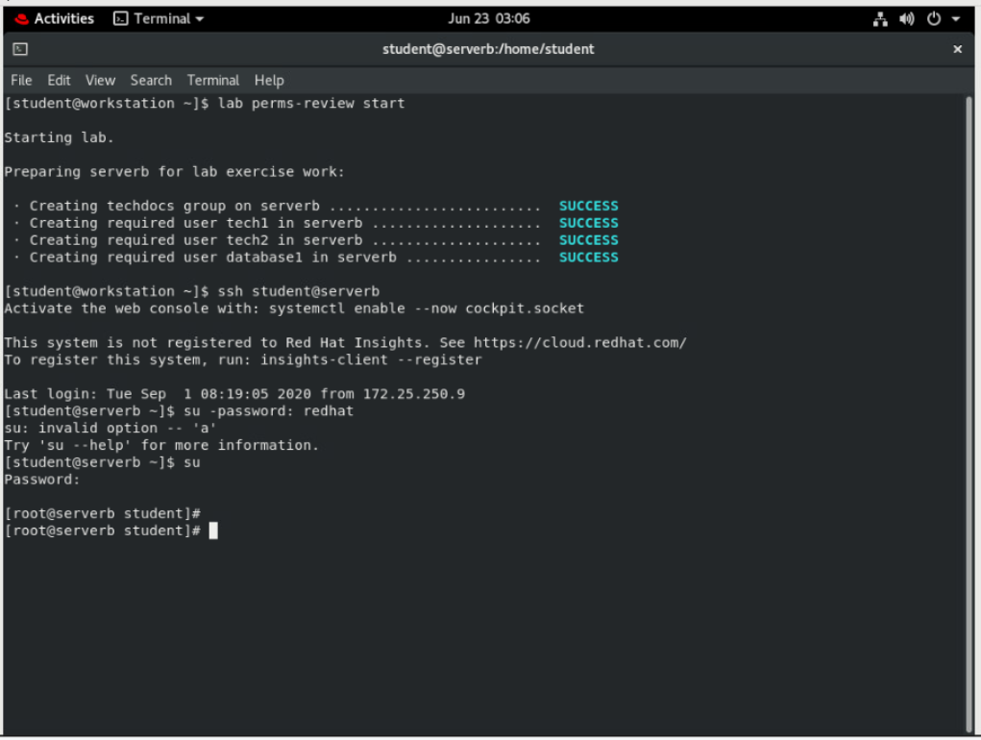

1. Create a directory called /home/techdocs.
   1. Use the mkdir command to create a directory called /home/techdocs.

**[root@serverb ~]# mkdir /home/techdocs**

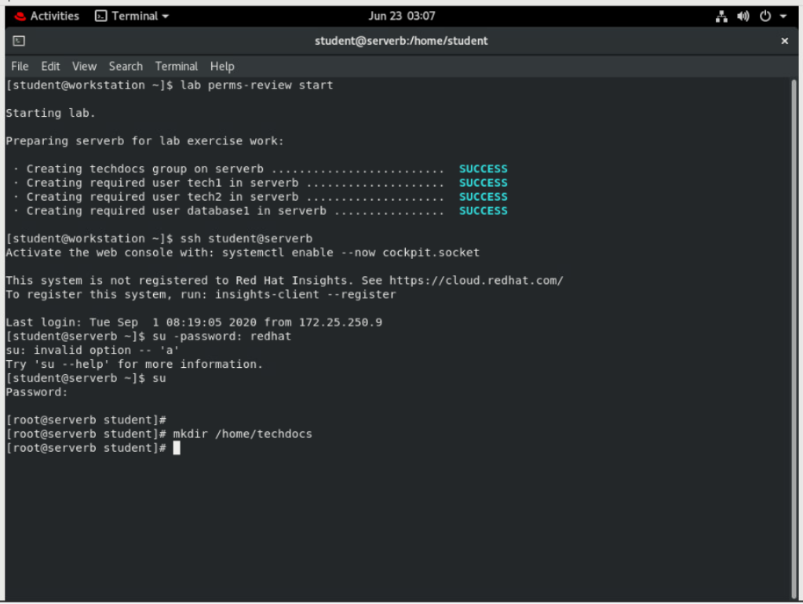

1. Change the group ownership of the /home/techdocs directory to the techdocs group.
   1. Use the chown command to change the group ownership for the /home/techdocs directory to the techdocs group.

**[root@serverb ~]# chown :techdocs /home/techdocs**

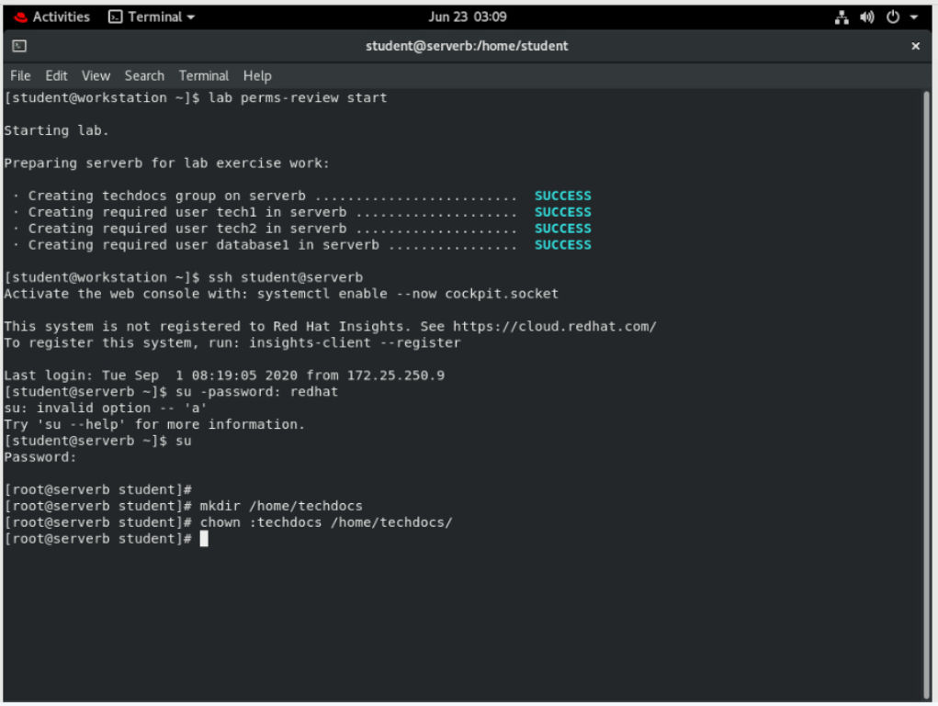

1. Verify that users in the techdocs group cannot currently create files in the /home/techdocs directory.
   1. Use the su command to switch to the tech1 user.

**[root@serverb ~]# su - tech1**

**[tech1@serverb ~]$**

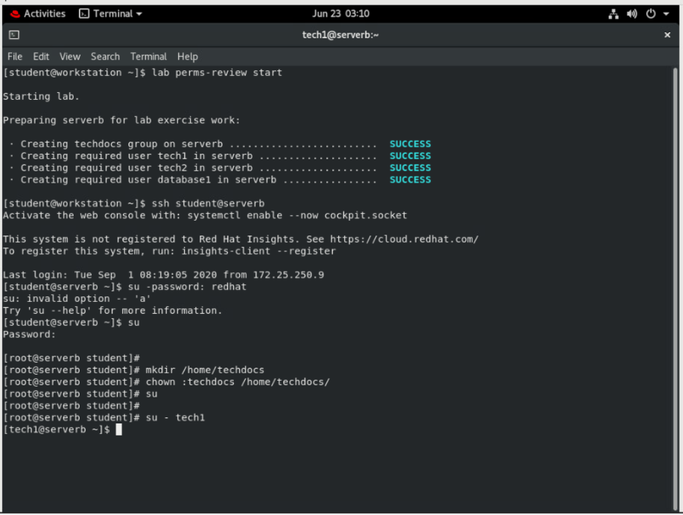

* 1. Use touch to create a file named techdoc1.txt in the /home/techdocs directory.

**[tech1@serverb ~]$ touch /home/techdocs/techdoc1.txt**

touch: cannot touch '/home/techdocs/techdoc1.txt': Permission denied

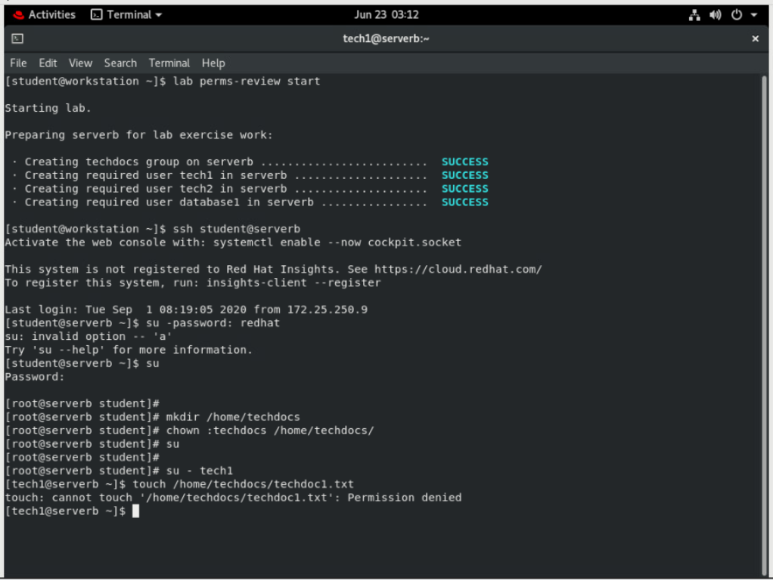

Note

Note that even though the /home/techdocs directory is owned by techdocs and tech1 is part of the techdocs group, it is not possible to create a new file in that directory. This is because the techdocs group does not have write permission. Use the ls -ld command to show the permissions.

**[tech1@serverb ~]$ ls -ld /home/techdocs/**

drwxr-xr-x. 2 root techdocs 6 Feb 5 16:05 /home/techdocs/

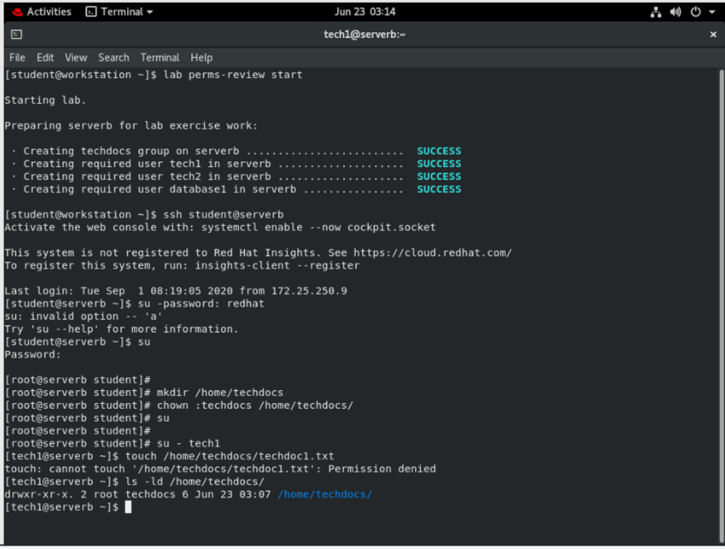

1. Set permissions on the /home/techdocs directory. On the /home/techdocs directory, configure setgid (2), read/write/execute permissions (7) for the owner/user and group, and no permissions (0) for other users.
   1. Exit from the tech1 user shell.

**[tech1@serverb ~]$ exit**

logout

**[root@serverb ~]#**

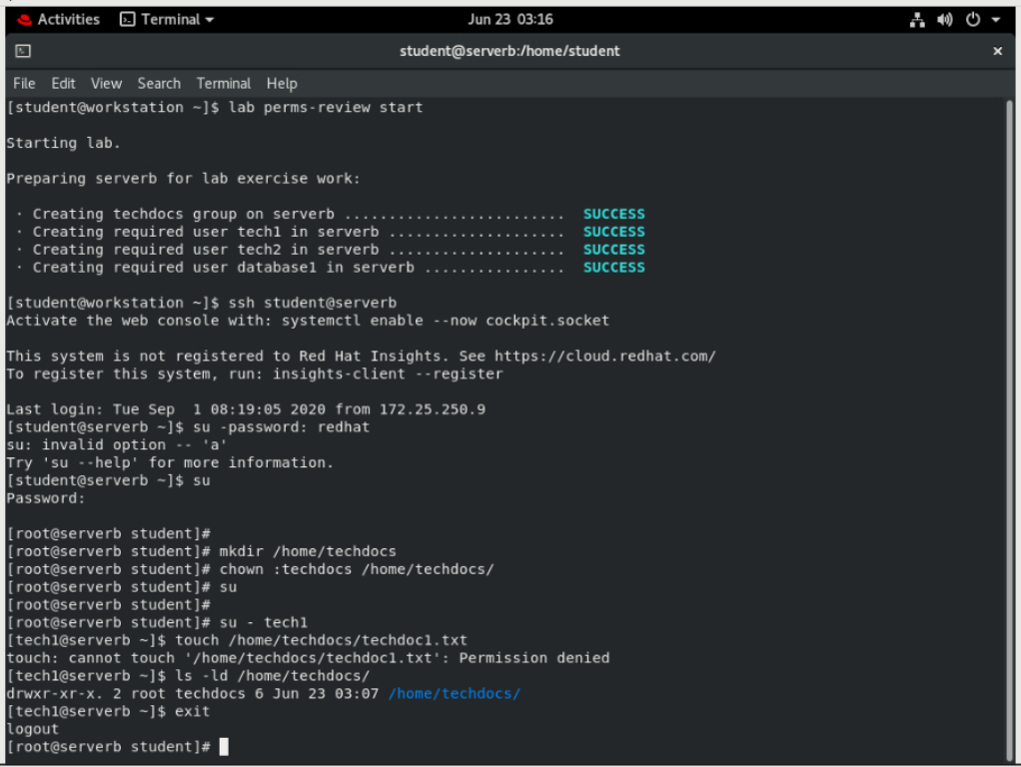

* 1. Use the chmod command to set the group permission for the /home/techdocs directory. On the /home/techdocs directory, configure setgid (2), read/write/execute permissions (7) for the owner/user and group, and no permissions (0) for other users.

**[root@serverb ~]# chmod 2770 /home/techdocs**

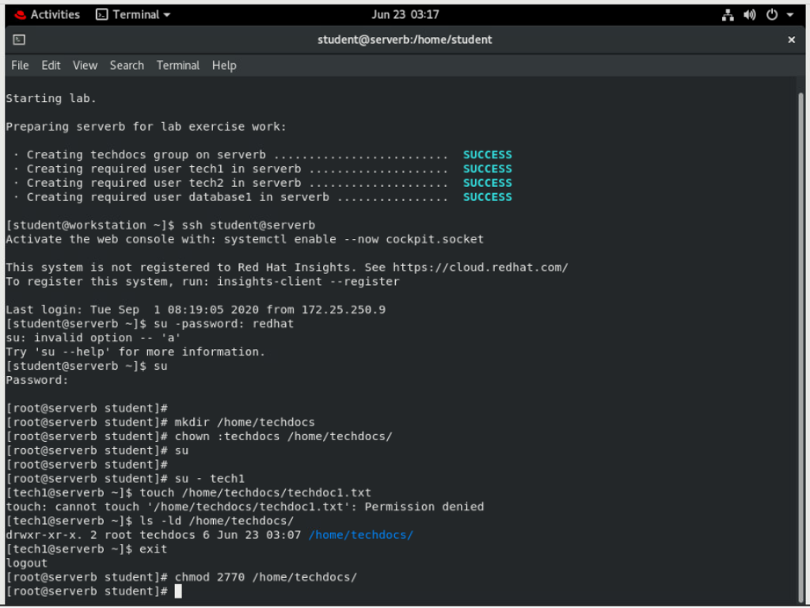

1. Verify that the permissions are set properly.

**[root@serverb ~]# ls -ld /home/techdocs**

drwxrws---. 2 root techdocs 6 Feb 4 18:12 /home/techdocs/

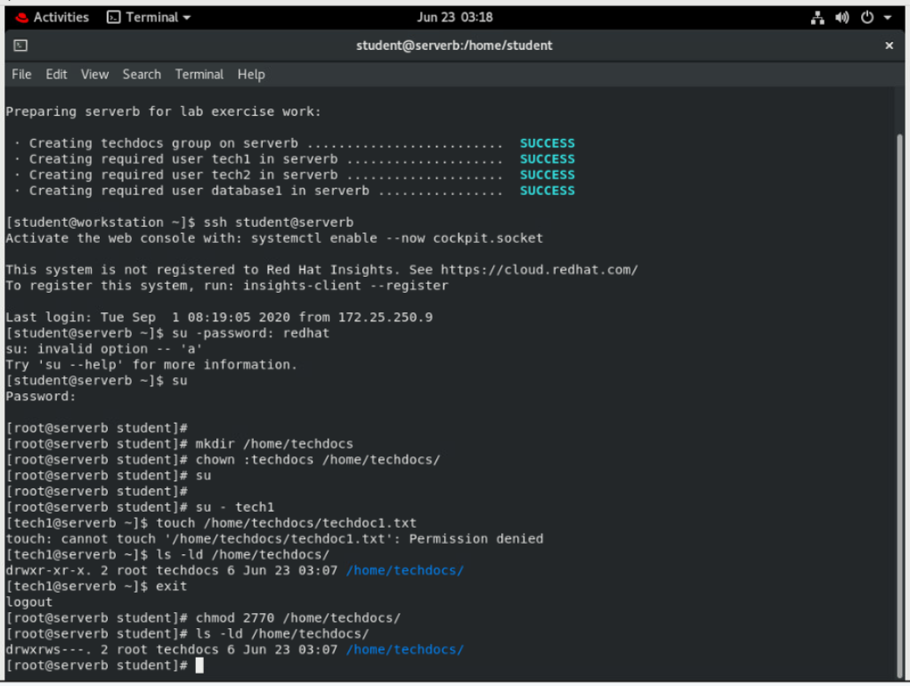

Note that the techdocs group now has write permission.

1. Confirm that users in the techdocs group can now create and edit files in the /home/techdocs directory. Users not in the techdocs group cannot edit or create files in the /home/techdocs directory. Users tech1 and tech2 are in the techdocs group. User database1 is not in that group.
   1. Switch to the tech1 user. Use touch to create a file called techdoc1.txt in the /home/techdocs directory. Exit from the tech1 user shell.

**[root@serverb ~]# su - tech1**

**[tech1@serverb ~]$ touch /home/techdocs/techdoc1.txt**

**[tech1@serverb ~]$ ls -l /home/techdocs/techdoc1.txt**

-rw-rw-r--. 1 tech1 techdocs 0 Feb 5 16:42 /home/techdocs/techdoc1.txt

**[tech1@serverb ~]$ exit**

logout

**[root@serverb ~]#**

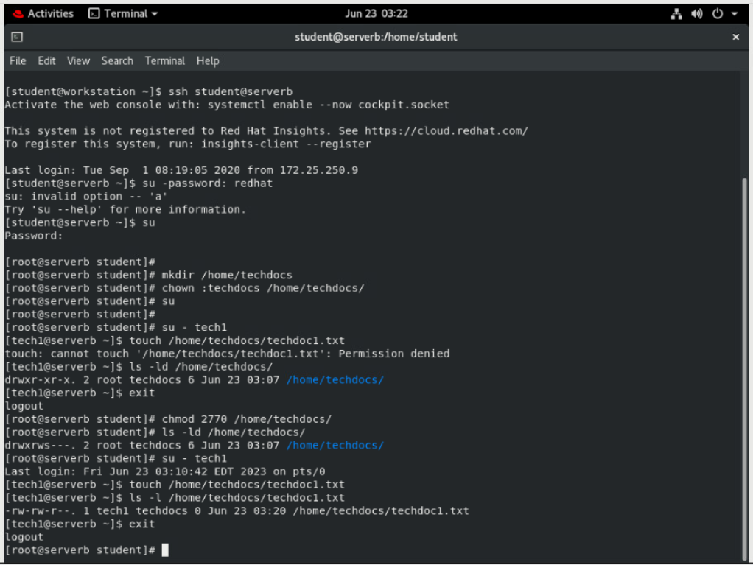

* 1. Switch to the tech2 user. Use the echo command to add some content to the /home/techdocs/techdoc1.txt file. Exit from the tech2 user shell.

**[root@serverb ~]# su - tech2**

**[tech2@serverb ~]$ cd /home/techdocs**

**[tech2@serverb techdocs]$ echo "This is the first tech doc." > techdoc1.txt**

**[tech2@serverb techdocs]$ exit**

logout

**[root@serverb ~]#**

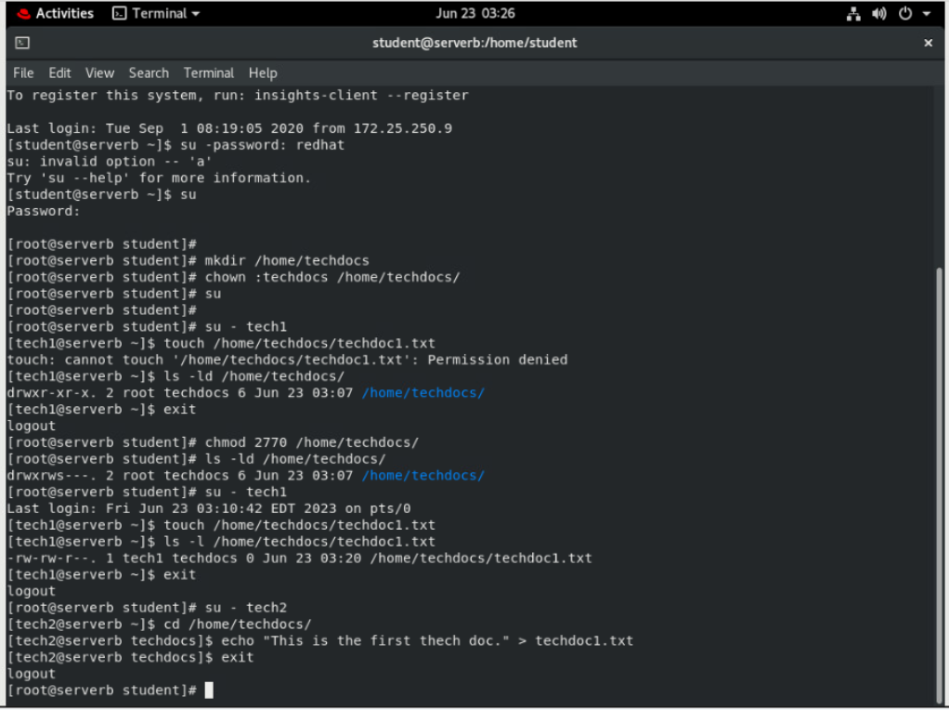

* 1. Switch to the database1 user. Use the echo command to append some content to the /home/techdocs/techdoc1.txt file. Notice that you will get a Permission Denied message. Use the ls -l command to confirm that database1 does not have access to the file. Exit from the database1 user shell.

The following echo command is very long and should be entered on a single line.

**[root@serverb ~]# su - database1**

**[database1@serverb ~]$ echo "This is the first tech doc." >> /home/techdocs/techdoc1.txt**

-bash: /home/techdocs/techdoc1.txt: Permission denied

**[database1@serverb ~]$ ls -l /home/techdocs/techdoc1.txt**

ls: cannot access '/home/techdocs/techdoc1.txt': Permission denied

**[database1@serverb ~]$ exit**

logout

**[root@serverb ~]#**

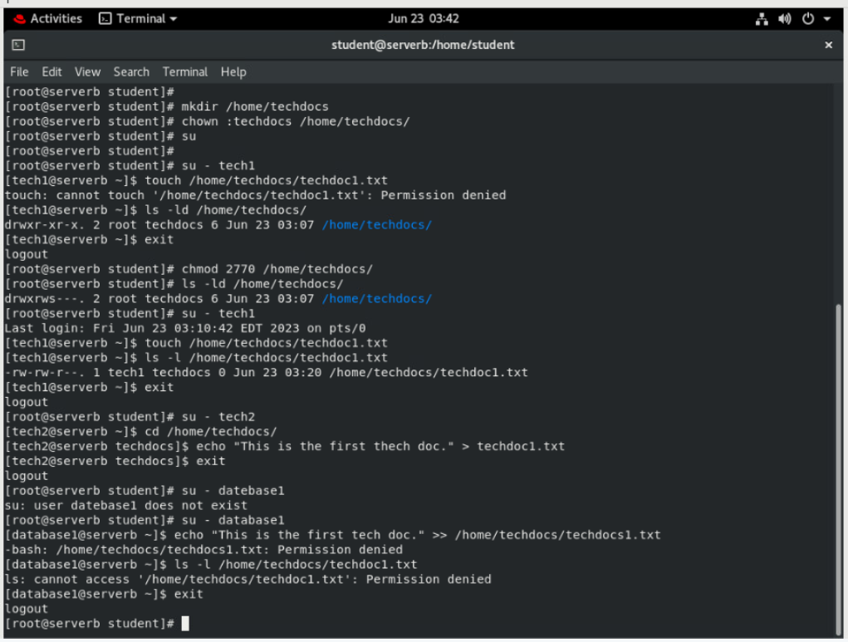

1. Modify the global login scripts. Normal users should have a umask setting that prevents others from viewing or modifying new files and directories.
   1. Determine the umask of the student user. Use the su - student command to switch to student login shell. When done exit from the shell.

**[root@serverb ~]# su - student**

**[student@serverb ~]$ umask**

0002

**[student@serverb ~]$ exit**

logout

**[root@serverb ~]#**

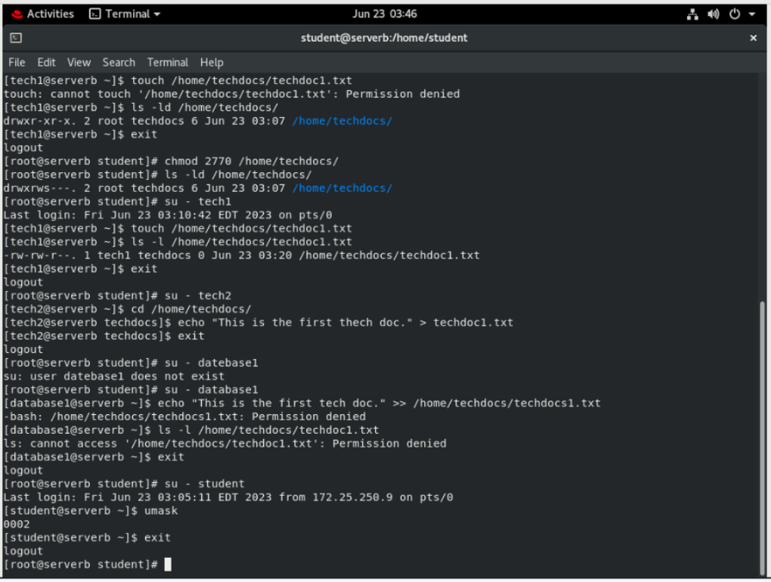

* 1. Create the /etc/profile.d/local-umask.sh file with the following content to set the umask to 007 for users with a UID greater than 199 and with a username and primary group name that match, and to 022 for everyone else:

# Overrides default umask configuration

if [ $UID -gt 199 ] && [ "`id -gn`" = "`id -un`" ]; then

umask 007

else

umask 022

fi

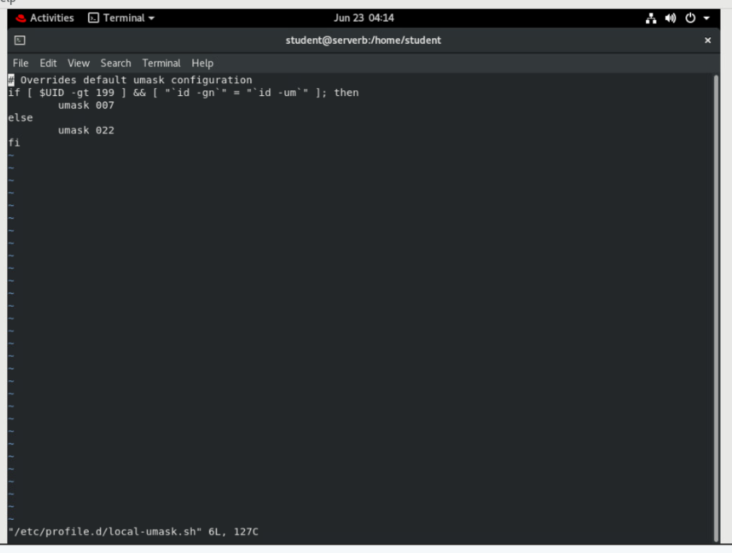

* 1. Log out of the shell and log back in as student to verify that global umask changes to 007.

**[root@serverb ~]# exit**

logout

**[student@serverb ~]$ exit**

logout

Connection to serverb closed.

**[student@workstation ~]$ ssh student@serverb**

*...output omitted...*

**[student@serverb ~]$ umask**

0007

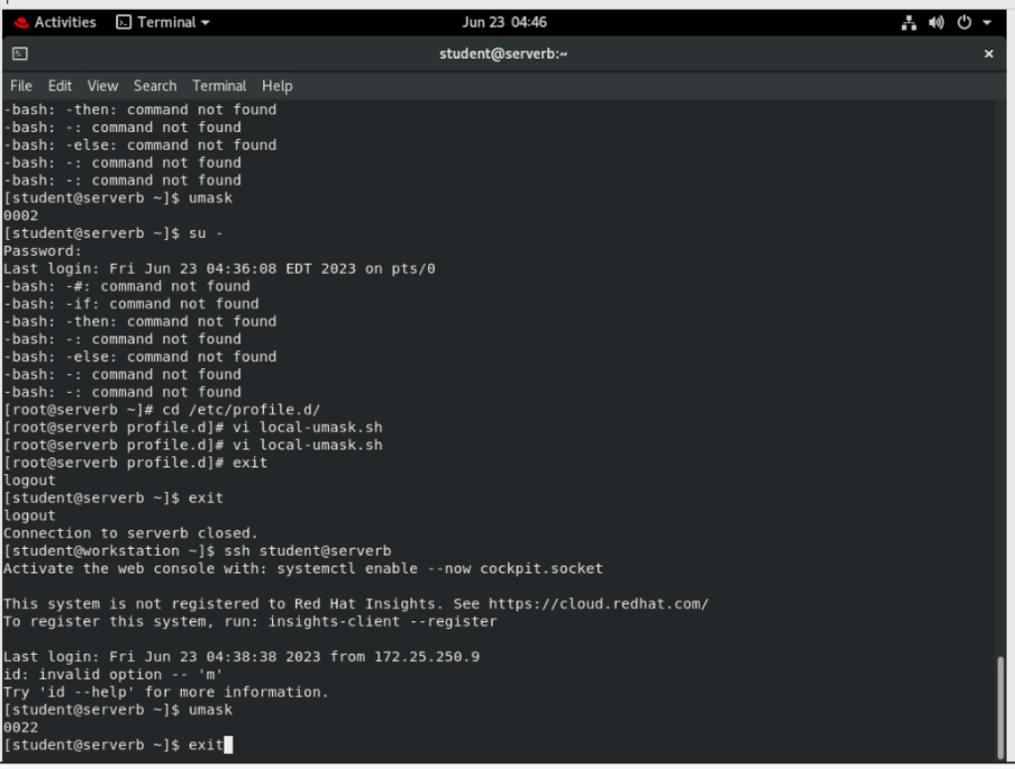

1. Log off from serverb.

**[student@serverb ~]$ exit**

logout

Connection to serverb closed.

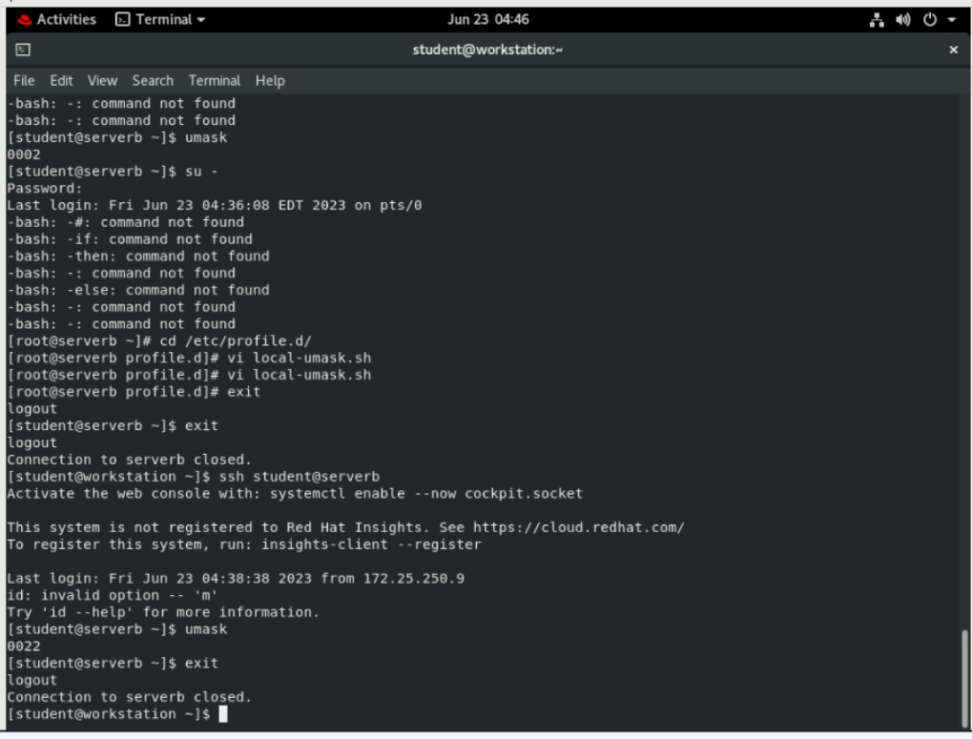

**Evaluation**

On workstation, run the lab perms-review grade script to confirm success on this exercise.

**[student@workstation ~]$ lab perms-review grade**

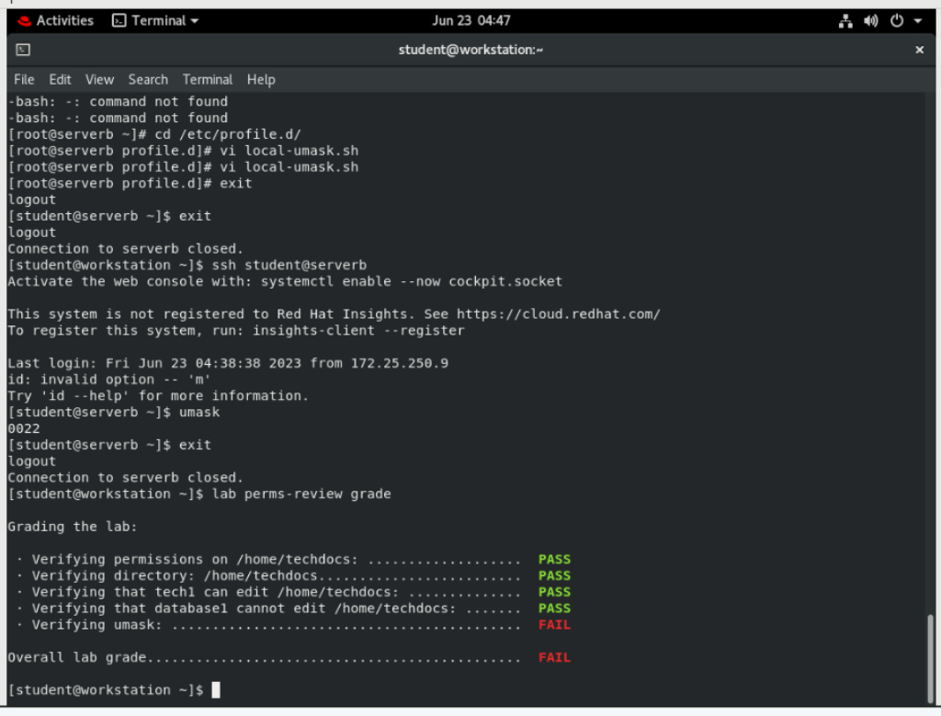

Gave up on the last one the directions / solution has to be wrong spent 1hr going back and forth try to get it to reed out 0007 but would not work.

**Finish**

On workstation, run the lab perms-review finish script to complete the lab.

**[student@workstation ~]$ lab perms-review finish**

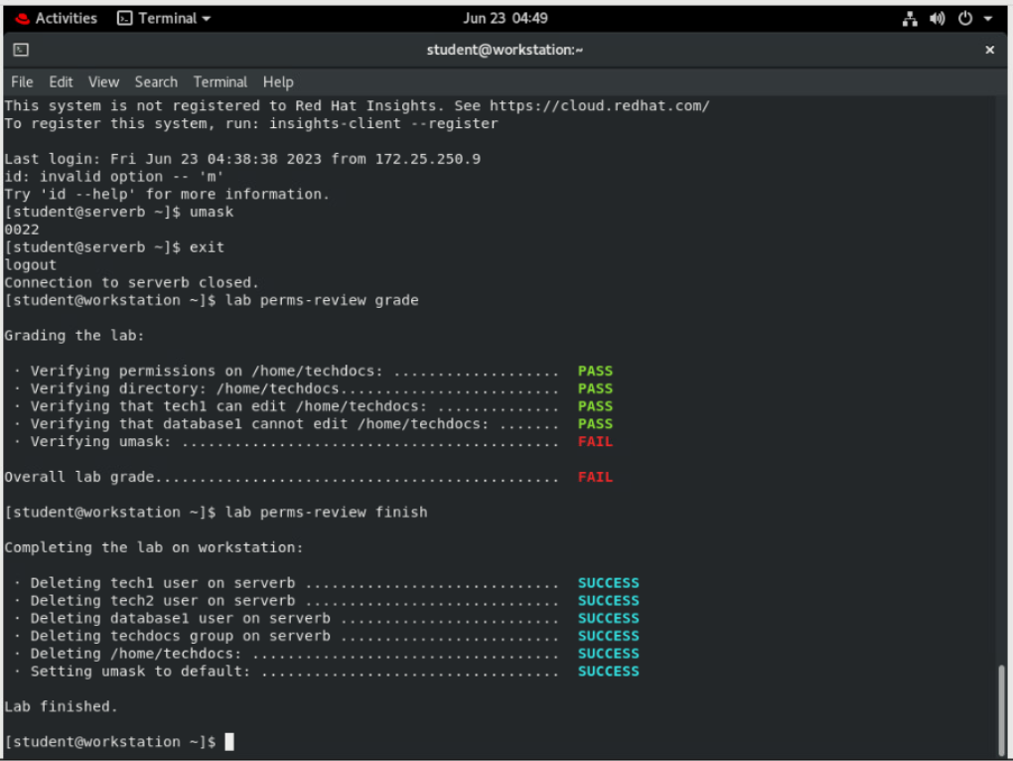

This concludes the lab.